Advanced Road Lane Line Detection

Ms. Visnu Dharsini

Assistant Professor

*Dept. of Computer Science Engineering SRM Institute of Science and Technology*

Chennai, India

[visnudhs@srmist.edu.in](mailto:visnudhs@srmist.edu.in)

Karthik K

*Dept. of Computer Science Engineering*

*SRM Institute of Science and Technology*

Chennai, India

[kk6931@srmist.edu.in](mailto:kk6931@srmist.edu.in)

M. Gopichandd

*Dept. of Computer Science Engineering*

*SRM Institute of Science and Technology*

Chennai, India

[mg3445@srmist.edu.in](mailto:mg3445@srmist.edu.in)

Jorige Venkatesh Sabarish S

*Dept. of Computer Science Engineering Dept. of Computer Science Engineering*

*SRM Institute of Science and Technology SRM Institute of Science and Technology*

Chennai, India Chennai, India

[jv4137@srmist.edu.in](mailto:jv4137@srmist.edu.in) [ss7431@srmist.edu.in](mailto:ss7431@srmist.edu.in)

***Abstract*— Lane detection systems are essential for driverless cars and sophisticated safety measures (ADASs). These detectors warn drivers of potential hazards in order to avert collisions. Type recognition and ego lanes give context. Lighting and driving conditions may hinder lane perception. We assess ego lane borders via CNN-based regression and YOLOv6. After spatial modification, lanes or road borders are validated by a network. Lane Net plus is advised for use as lane markers and side segmentation. It constructs a multitasking network, divides it by semiology, generates encapsulated space networks, and clusters lane lines to segment instances. This warrants investigation. Combining the spatial and semantic network loss functions for segmentation provides the total network loss function. In the training dataset, 12,000 pixel-tagged dashcam images and 90,000 iterations are included. 12-hour model trained on the server. dual GPUs Models are 95% correct.**

***Keywords— RGB, CNN, RNN, YOLO V6, ROI, Otsu Canny, and Hough Transform.***

**I. INTRODUCTION**

This paper proposes a vision-based lane identification algorithm that is accurate and resilient to illumination and shadows. The car's camera will capture the front angle/view before identifying lane lines. These lanes are recovered using the Hough transform and two hyperbolas. The lane-detecting technology works on straight and curved roads, painted and unpainted, in every weather. Lane detection uses edge and line detection. Line detection is AI improves automatic driving technology.

We use feather and model methods. Given the speed at which motorists travel on roadways, we propose a lane recognition system that is effective in complicated traffic scenarios. Examples of techniques include feather and model. We suggest for a lane identification system that is effective in heavy traffic given the speed at which people travel.

Automatic driving needs an algorithm that works in a wider variety of situations. Traditional lane recognition functions need manual development and time-consuming post-processing. In complicated traffic, this method does not meet the requirements of an autopilot. Numerous people use deep learning to avoid this constraint.

**II. LITERATURE REVIEW**

Li, Haixia, and Li Xizhqou [1] introduced a revolutionary proposal based on segmenting and classifying self-encoding and decoding networks in 2021. It discovered and categorized lane boundaries quickly. The model had no peers. Samia Sulthana and Boshir Ahmed [2] proposed an automated adjustable threshold (AAT) for the canny edge detector, which obtained 97.4% accuracy in light rain and 92% accuracy in severe rain, but fails in curved lane situations.

Sayyidul Aulia Alamsyah's [3] article on the same could detect lane signs even if the roads lacked them, but it has not been implemented as there are no solutions for roads with curves. Samia sultana [4] recommended SAGC evening features. The processing time is quick and may be used in real-time applications, although it is not optimal for curved routes and inclement weather has not been taken into account.

Long Yang Ma's [5] real-time results are more accurate on wet and overcast days when employing yellow roads and heavy exposure like fog and snowfall. Huan Shen [8] proposed picture's enhancement uses retinax and gamma. Grey-weighted Hough transform may hinder lane line identification.

Using Zongze Ye’s [9] theory, CNN and RANSAC may be used to identify a vehicle's lane. Resnet-18 assists autonomous cars in producing more precise conclusions. The model created by Hongru Hou, Pute Guo [6], and Unet could identify lanes in subways and mountains, but it needed improvement. In addition, unneeded pixels on the classification surface distorted lane detection, hence the state transitional model was selected.

# J. Han's [7] model helps find the lane by the white lines in any situation. Ahmed Hashem [10] employs line transformation and sliding window approach to improve distorted bending lanes. This straightened non-lane lines and smoothed curves. Hongyu Zhou's [11] paper technique was excellent for almost precise results but hard to discern in dim circumstances.

# III. EXISTING SYSTEM

# The edge information of lane markers is used to determine lane lines. Hough, Radon, etc. transforms fit lane lines. Edges are identified using Sobel's, Canny's, and other methods. This approach is restricted, and certain photographs need intentionally adjusted settings. This study offers an Otsu-Canny-based straight-line recognition approach using YOLOv6. Figure 1 [12] compares Sobel's and Otsu's approaches, while Figure 2 [18] compares YOLO benchmarks.

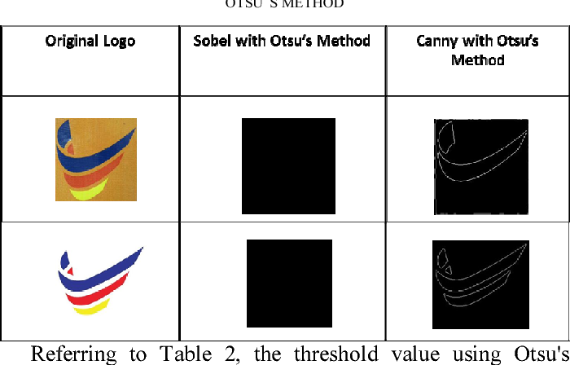

Figure 1. Sobel against Otsu Canny

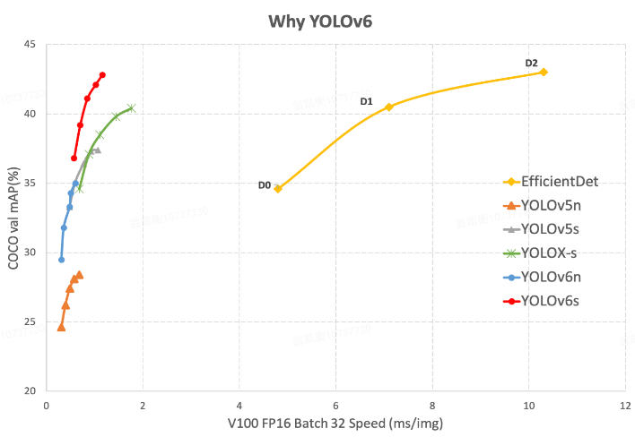

Figure 2. Benchmarks for YOLO versions

**IV. PROPOSED SYSTEM**

**A. Image Pretreatment**

Uneven lighting and road surface produce vibrations and noise when a vehicle's camera takes photos of the road. In addition to lane feature points, road images captured by a moving camera include extraneous information. Image preprocessing comprises edge detection, grayscale image processing, and ROI extraction.

1. Extraction of the Region of Interest (ROI)

The majority of pictures captured by car cameras have minimal effect on lane line extraction, such as tree shadows, people and other vehicles on the road, the sky above the image, etc., as seen in Figures 3(a) and 3(b) for the original image and the region of interest, respectively.

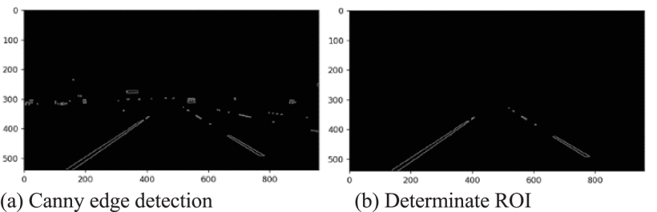

Figure 3(a) and 3(b)

2. Image Grayscale

Graying the RGB picture speeds up the processing time. Figure 4 demonstrates grayscale. The weighted average approach is used to determine graying.

Gray = ((0.3 * R) + (0.59 * G) + (0.11 * B)) …… (1)

The study uses the following grayscale formula given that lane lines are white (255,255,255) and yellow (255,255,0)

Gray = ((0.5 × R) + (0.5 × B)) …………….….…. (2)

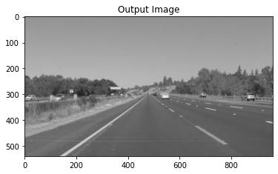

Figure 4. Output subsequent to Grayscale

3. Enhancing the Image’s Contrast

Improving a picture entail minimizing or deleting unnecessary or distracting elements while emphasizing key ones in order to enhance detection accuracy. Spatial and transform image enhancement. Transforming a picture affects its context. "Spatial histogram equalization" is used. Non-linear stretching and rescaling may increase picture contrast by evenly distributing grayscale values. We have a histogram and a black-and-white picture in this instance. The lane line of the picture is more noticeable after equalization.

4. Median Filtering

Weather, uneven illumination, and other elements produce noise in photographs of roads in the actual world, impacting the accuracy of image processing. Image filtering decreases image noise. Enhancements to an image may be spatial or frequency-based. Using frequency domain filtering to process images is too time-consuming to achieve design objectives. Mean and median filtering are two techniques for spatial domain image processing. Wet and snowy conditions are common for road identification, generating image noise. The underlying image is filtered using a salt-and-pepper filter at 0.05 Hz to simulate noisy spots. Figure 5 [13] depicts the thirty-third filter window.

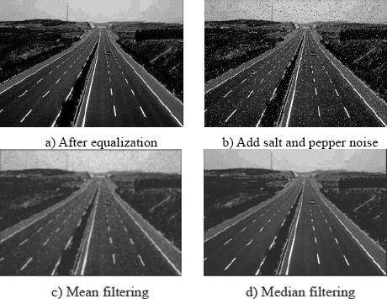

Figure 5. A Comparison of Filtration Methods

**B. Detection of the Lane Line Edges**

The interference data are still there even after the road image has been filtered. When done properly, edge detection has the potential to reduce the size of a picture's file without negatively impacting the image's quality. Methods such as Canny, Sobel, Robert, and Prewitt are examples of ways that may be taken to edge detection. The results of the investigation into edge detection are shown in figure 5. The information regarding the margins is completely lacking, as seen by Figure 6. In their detection methods, both Sobel and Prewitt use information about fuzzy edges. The detection provided by Canny causes the smoothing off of sharp edges. Lane lines are restored with the assistance of advanced edge detection, and noise levels are reduced to the fullest degree that is practically possible.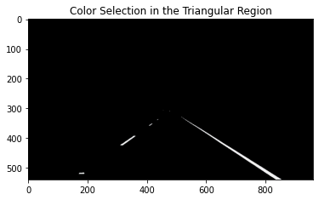

Figure 6. Edge detection by Sobel

The Otsu method may duplicate the features of the Canny algorithm, which modifies the threshold based on picture data [14] - [15]. This entry serves as the Canny low threshold and is created using the Otsu technique [16] - [17] by leveraging the image's differentiating properties. Figure 7 shows the results of Canny with a customizable threshold.

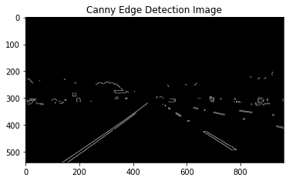

Figure 7. Edge detection using Otsu-Canny

**C. Hough Transform using Slope Filtering**

The Hough algorithm modifies the edge picture from the prior phase. Hough transform is shown by line normal. A normal is a direction that goes through the origin perpendicularly. The boundary image is converted to Hough space. The x-axis in Hough space represents the normal angle, whereas the y-axis represents the perpendicular.

The equation is = xcosƟ + ysinƟ is the distance perpendicular to the origin and normal-horizontal angle. A point on a cosine curve represents a Hough edge picture. Multiple points on a line cause the cosine curves in Hough space to cross in a different (sin, cos) pair. When crossings reach a crucial value, a (sin, cos) pair shows the line. The Hough transform detects lines that resemble lanes. Some possible lanes may be false positives. The lane analysis permits an x-axis change of 15 to 85 degrees. Potential lanes with steep or shallow slopes will be rejected by the filter. False-positives are eliminated. Rejection is flawed. It is possible for structures, shadows, and other vehicles to form lines parallel to authentic lane markers that survive slope filtering and provide false warnings.

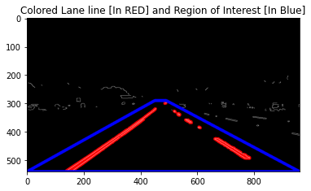

Figure 8. After applying Hough Transform

**D. Selection of Lanes and Interframe Clustering**

Figure 9 depicts the process of inter-frame clustering and lane selection. Inter-frame clustering eliminates lane candidates from incorrectly identified lines. Parallel lines are not subject to slope filtering. Lane markers change from frame to frame, yet parallel lines never vanish. False lane candidates consist of lines that are present in several video frames or whose position varies. Similar lines in successive frames are grouped by increasing the matching cluster weight, hence reducing the number of feasible lanes. It uses and values to determine if a newly detected line belongs to an existing cluster and its relative placement. Each frame adds a new line cluster or grows an existing line cluster, therefore renewing the cluster database. Image frame influences whether lines are grouped to the left or right. Finally, it selects left and right lines that are equidistant from the middle of the lane. Several lines have cluster weights larger than the bare minimum.

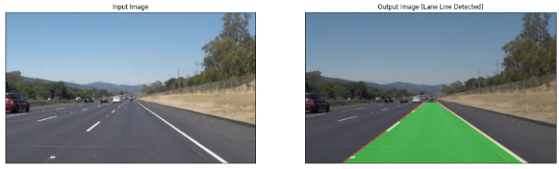

Figure 9. Lane selection implemented

**V. ALGORITHM-USED**

This work makes use of YOLOv6. This approach identifies items using an effective, one-step framework. In terms of detection accuracy and inference speed, it exceeds YOLOv5. To balance operator expressiveness and computational expense, YOLOv6 has a decoupled head structure.

**VI. EVALUATION AND RESULTS**

**A. Performance assessment:**

The outcomes of the suggested approaches were compared to the baseline. By preprocessing the picture, precise lane selection was accomplished. Accurate lane extraction was made feasible in part by the ROI's lane centering feature and the median filter's background noise reduction capabilities.

**B. Results:**

In actuality and the Caltech dataset, curbs are not considered lanes. Even though our system can identify the lack of lane markings at the crossroads junction in the dataset, the ground truth data does not. The proposed method can discern lanes consistently despite shadows, writing, opacity, and moving vehicles. The data is consistent with the majority of lane detection strategies. The provided approach for lane identification is applicable to any dataset. Constant lane identification is provided by curbs and intersecting lane lines. It can also detect curved lane lines if they are piecewise linear, however sudden curve sharpness hinders its performance. We may test the lane-detection algorithm on one of the several lane datasets already available.

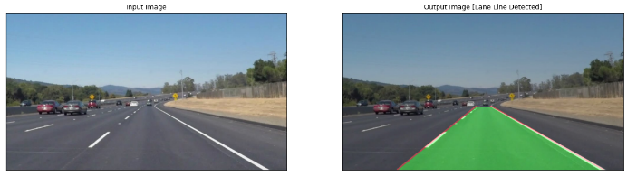

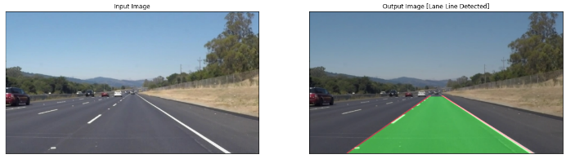

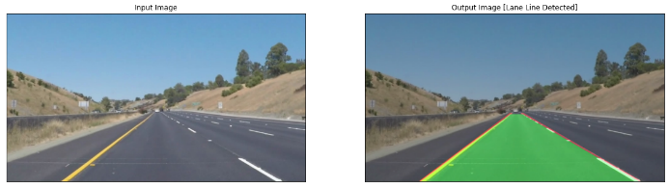

# Figure 10. Output Screenshot

# VII. CONCLUSION

The detection of lane lines was accomplished using CNN (Convolutional Neural Network) techniques. YOLOv6 is a breakthrough single-stage object recognition system with outstanding performance. This method detects objects more rapidly and has a higher mapping value than previous real-time techniques. Because of its accuracy and velocity, YOLO architecture is suitable for future operating systems. After the Canny transform, apply the Gaussian blur filter. Success depends on selecting the proper location (ROI). In addition, Hough transform and lane-finding are used. In preliminary testing, the algorithm performed well. The effectiveness of the lane recognition and tracking technology will be determined by actual traffic conditions.

# VIII. REFERENCES

[1] L. Haixia and L. Xizhou, "Flexible lane detection using CNNs," 2021 International Conference on Computer Technology and Media Convergence Design (CTMCD), 2021, pp. 235-238, doi: 10.1109/CTMCD53128.2021.00057.

[2] S. Sultana and B. Ahmed, "Lane Detection and Tracking under rainy weather challenges," 2021 IEEE Region 10 Symposium (TENSYMP), 2021, pp. 1-6, doi: 10.1109/TENSYMP52854.2021.9550931.

[3] Alamsyah, Sayyidul & Purwanto, Djoko & Attamimi, Muhammad. (2021). Lane Detection Using Edge Detection and Spatio-Temporal Incremental Clustering. 364-369. 10.1109/ISITIA52817.2021.9502232.

[4] S. Sultana and B. Ahmed, "Robust Nighttime Road Lane Line Detection using Bilateral Filter and SAGC under Challenging Conditions," 2021 IEEE 13th International Conference on Computer Research and Development (ICCRD), 2021, pp. 137-143, doi: 10.1109/ICCRD51685.2021.9386516.

[5] Long. Yang. Ma, H. Zhu and H. Duan, "A Method of Multiple Lane Detection Based on Constraints of Lane Information," 2021 China Automation Congress (CAC), 2021, pp. 4059-4064, doi: 10.1109/CAC53003.2021.9727491.

[6] Hou, Hongru & Guo, Pute & Zheng, Bin & Wang, Junjie. (2021). An Effective Method for Lane Detection in Complex Situations. 1-4. 10.1109/ISNE48910.2021.9493597.

[7] J. Han and C. Lee, "Color Lane Line Detection Using the Bhattacharyya Distance," 2020 11th International Conference on Information, Intelligence, Systems and Applications (IISA, 2020, pp. 1-4, doi: 10.1109/IISA50023.2020.9284147.

[8] H. Shen, "Complex Lane Line Detection Under Autonomous Driving," 2020 5th International Conference on Mechanical, Control and Computer Engineering (ICMCCE), 2020, pp. 627-631, doi: 10.1109/ICMCCE51767.2020.00139.

[9] Z. Ye, "Fast Multi-direction Lane Detection," 2021 2nd International Conference on Computing and Data Science (CDS), 2021, pp. 301-304, doi: 10.1109/CDS52072.2021.00059.

[10] A. Hashem and T. Schlechter, "Feature-Based Lane Detection Algorithms for Track Following: A Comparative Study," 2022 8th International Conference on Mechatronics and Robotics Engineering (ICMRE), 2022, pp. 169-173, doi: 10.1109/ICMRE54455.2022.9734077.

[11] H. Zhou and X. Song, "Lane Detection Algorithm Based on Haar Feature Based Coupled Cascade Classifier," 2021 IEEE Asia-Pacific Conference on Image Processing, Electronics and Computers (IPEC), 2021, pp. 286-291, doi: 10.1109/IPEC51340.2021.9421278.

[12] Beeran Kutty, Suhaili, Shuria Saaidin, Puteri Nor Ashikin Megat Yunus and Suhana Abu Hassan. “Evaluation of canny and sobel operator for logo edge detection.”2014 International Symposium on Technology Management and Emerging Technologies*(2014): 153-156.*

[13] Qin Min, A Research of Lane Detection and Tracking Based on Machine Vision[D], Ocean University of China, 2012.

[14] Yu Xiaohai, Zhang Yang and Xu Ying, "An Improved Adaptive Threshold Canny Algorithm[J]", Machinery & Electronics, vol. 38, no. 01, pp. 6-9, 2020.

[15]Song Renjie, Liu Chao and Wang Baojun, "Adaptive Canny edge detection algorithm[J]", Journal of Nanjing University of Posts and Telecommunications (Natural Science), vol. 38, no. 03, pp. 72-76, 2018.

[16] N. Otsu, "A Threshold Selection Method from Gray-Level Histograms", IEEE Transactions on Systems Man and Cybernetics, vol. 9, no. 1, pp. 62-66, Jan. 1979.

[17] Cai Yonghua and Zhou Zhiyong, "Structured Road Lane Marking Identification Based on the Improvement of Otsu Method[J]", Journal of Wuhan Technical College of Communications, vol. 22, no. 04, pp. 101-107, 2020.

[18] Source of the Image: <https://dagshub.com/blog/content/images/size/w1000/2022/06/Untitled--5-.png>